BAHRIA UNIVERSITY KARACHI CAMPUS
Department of Computer Science

APPLIED PHYSICS

LAB EXPERIMENT # 7

RLC Acceptor circuit

OBJECTIVE:-

- To study the characteristics of Acceptor circuit and the determine the value of Inductance

EQUIPMENT:-

- Series RLC Circuit Trainer,
- Function Generator.

THEORY:-

Acceptor circuit is a series RLC circuit. It is called acceptor circuit because it accepts maximum current at certain frequency called the resonant frequency or in other words it offers minimum impedance at resonant frequency.

R (Ω)
C (μ F)
L (mH)
AC signal
μ A

The equivalent impedance of series RLC circuit can be written as the sum of individual impedances of R, C & L.
i.e.
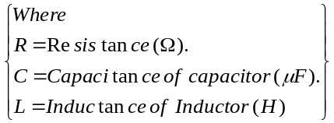
Z = Z_{R} + Z_{C} + Z_{L}
= R + 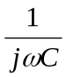+ jωL
= R –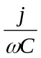 + jωL
= R + j(ωL – 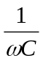) - - - - - - - - - - - - - - (i)
Here;
Real Part of Z = R
Imaginary part of Z = (ωL –)

The nature of the load depends upon the sign of the result of imaginary part of Z.
Three possible cases are;
- If (ωL – 1/ωC) > 0; The load is Inductive.
- If (ωL – 1/ωC) < 0; The load is Capacitive.
- If (ωL – 1/ωC) = 0; The load is purely Resistive.

RESONANT FREQUENCY:-

“The frequency at which impedance of the series RLC circuit or admittance
of the parallel RLC circuit is purely Real is called the resonant frequency
and the circuit at this frequency is said to be in resonance”.

Under resonance, the imaginary term of impedance is zero i.e.

ωL –= 0
Simplifying;
ω²L = 

or ω² = 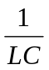
eq (1)
ω = 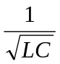
or (ω denotes angular frequency)

Where angular frequency ω = 2πf
Eq (1) gives the resonant frequency of the acceptor circuit. Let us denote resonant frequency with ω_{r}
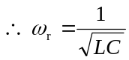
eq (2)

(ω) = 2πf

 (ω_{r}) = 2πf_{r}

Therefore eq (2) becomes,

f_{r} = 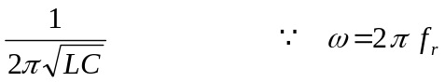

When input signal is f_{r,} then
Z = R
And | Z | = R
This shows that impedance is minimum at resonant frequency.

PROCEDURE:

- Set the amplitude of the input at such a level that ammeter starts to detect the current in the series circuit.
- Apply sinusoidal voltage at the input of acceptor circuit with frequency 800 Hz.
- Proceed the experiment by increasing frequency in steps of 100 Hz
- Record the frequencies and respective current values.
- Plot the graph between f v I and log f v I .

| Z | (ohm)
I (μA)
f_{r}
F (Hz)
I (μA)
| Z | (ohm)
- Locate the frequency on the graph where current is maximum, this is the resonant frequency f_{r}.
- With the help of resonance frequency, find the value of inductance L of inductor using the following formula.
2πf =
or 4π²f _{r}² = 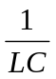

or L = 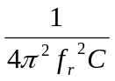

(C=0.01μ F)

OBSERVATIONS:-

S.No. | Frequency ’f’ (Hz) | Current I (μA) | log f
1
2
3
4
5
6
7
8
9
10
11
12
13
14
15
16
17
18
19
20

RESULTS:- (C=0.01μ F)

1. Observed resonant frequency = __________________

2. The calculated value of inductor = ________________

Note: Show all performed calculations.

Teacher Signature: ________________________

Student Registration No: ________________________

